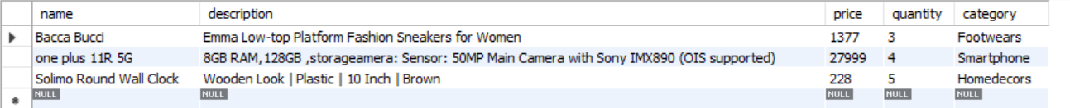

When price is less than 2000



Quantity is >3



Updating price of clock to 199



Deleting Bacca Bucci’s row from table



